Module Name:
Wikipedia Search – Requirement Review & Inspection
Test Case ID: WIKI_RR_01
Webpage URL: https://www.wikipedia.org

Scenario ID: 1a
Scenario: Review the Wikipedia homepage and verify the search feature requirements.
Test Steps:
- Open https://www.wikipedia.org
- Verify the homepage loads successfully.
- Check the search box is visible.
Screenshots: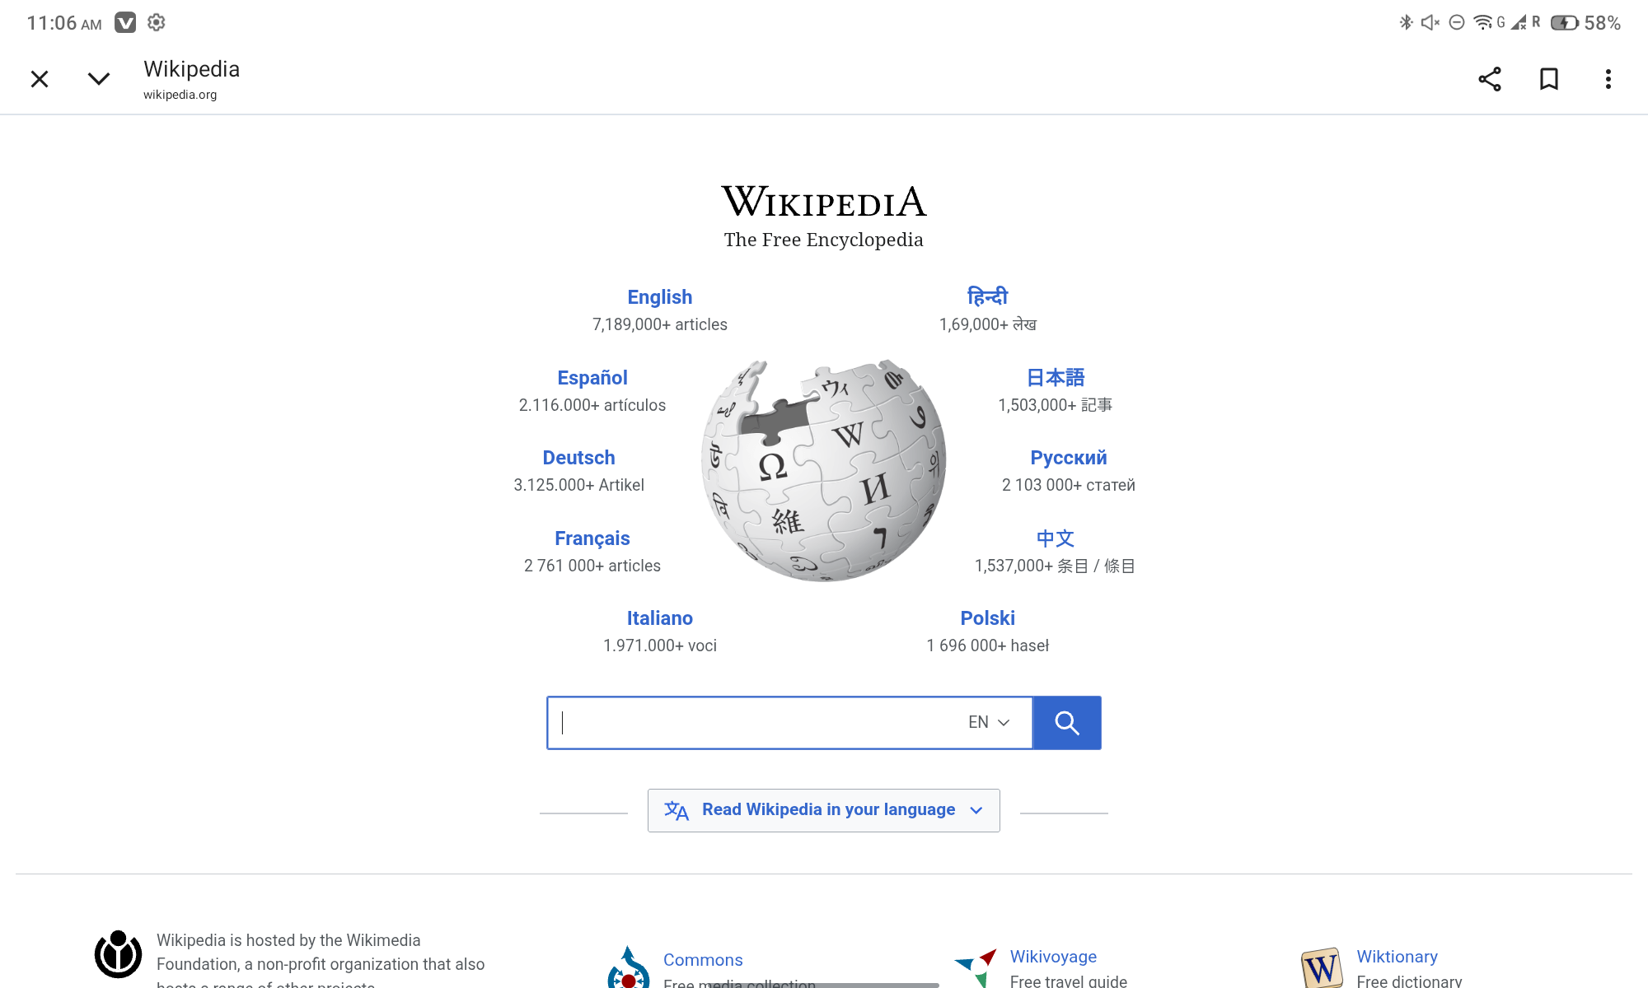

Scenario ID: 1b
Scenario:Search using a valid keyword.
Test Steps:
- Enter Artificial Intelligence.
- Click Search.
Screenshots:
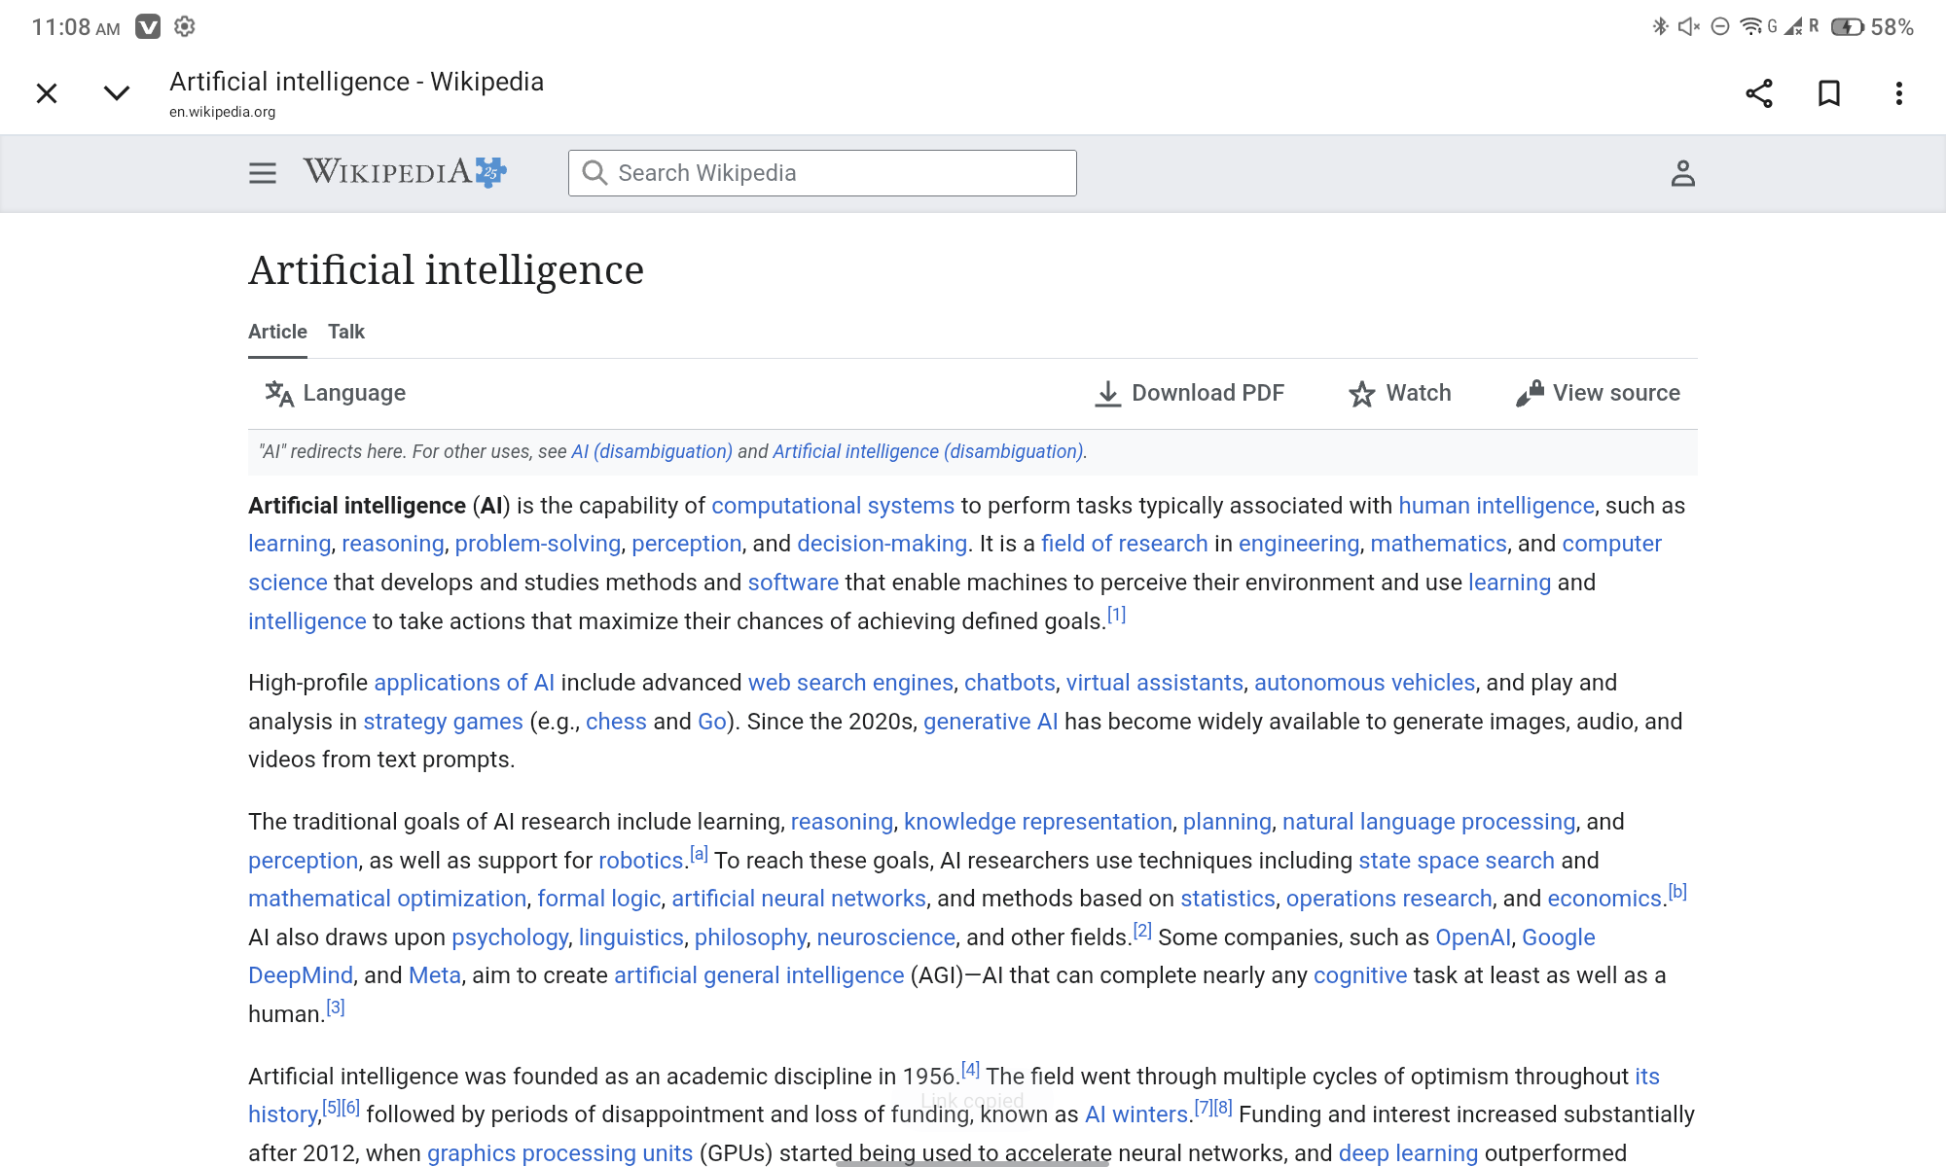
Scenario ID: 1c
Scenario:Verify search results relevance.
Test Steps:
- Review the displayed search results.
- Verify they match the entered keyword.
Screenshots:
Scenario ID: 1d
Scenario:Open the first search result.
Test Steps:
- Click the first article.
- Verify the article page opens correctly.
Screenshots: 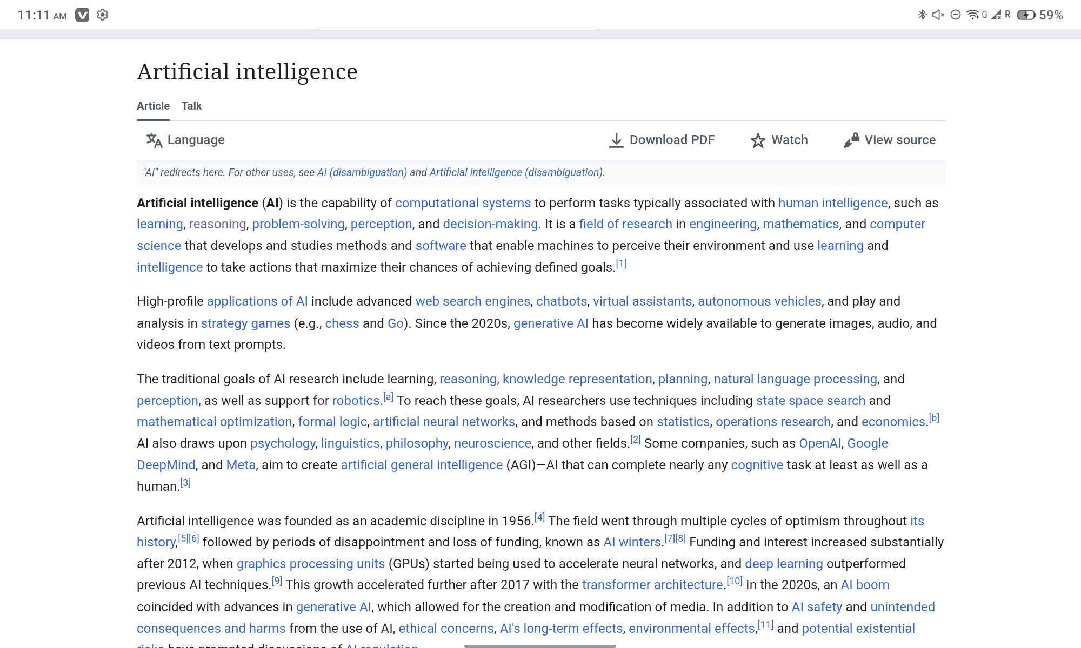
Scenario ID: 1e
Scenario:Review page navigation.
Test Steps:
- Scroll through the article.
- Verify headings and links work properly.
Screenshots:
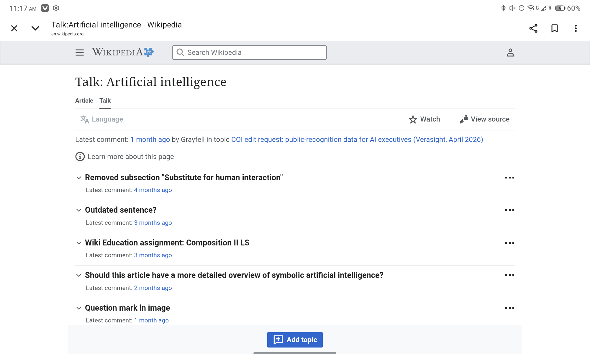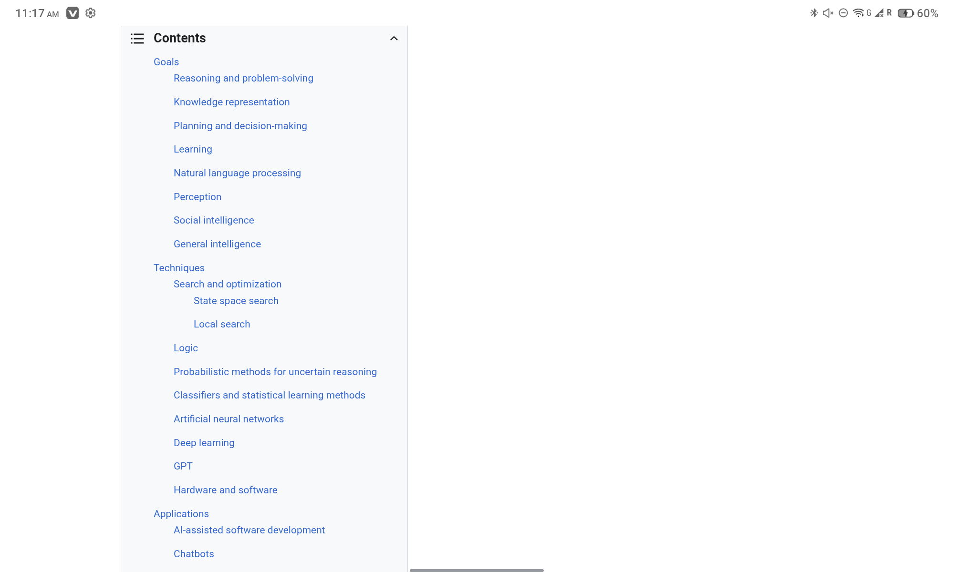
Scenario ID: 1f
Scenario:Check responsiveness.
Test Steps:
- Rotate the tablet screen.
- Verify the layout adjusts correctly.
Screenshots:
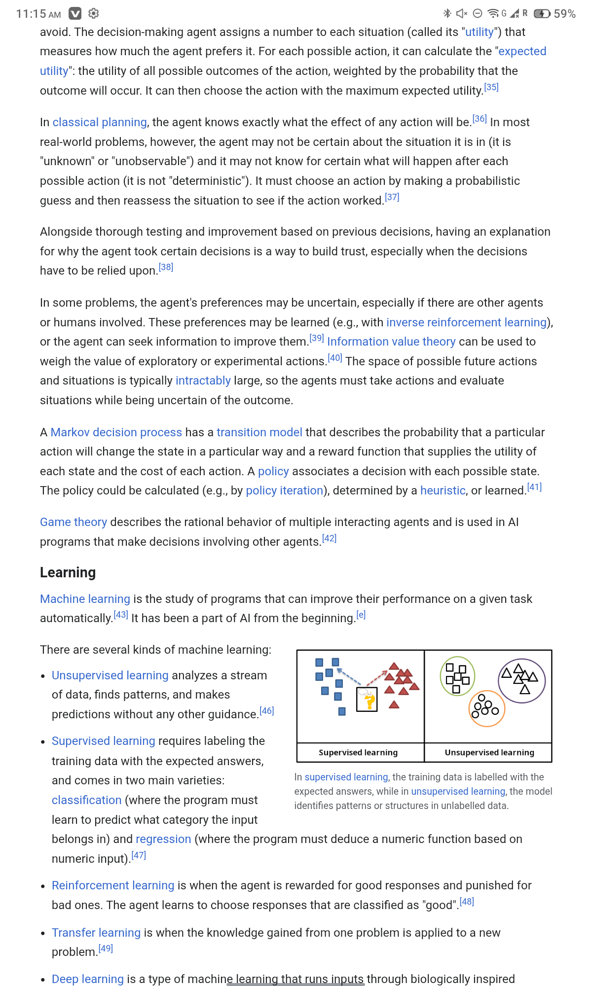
Scenario ID: 1g
Scenario:Verify hyperlinks.
Test Steps:
- Click an internal Wikipedia link.
- Verify the linked page opens.
Screenshots: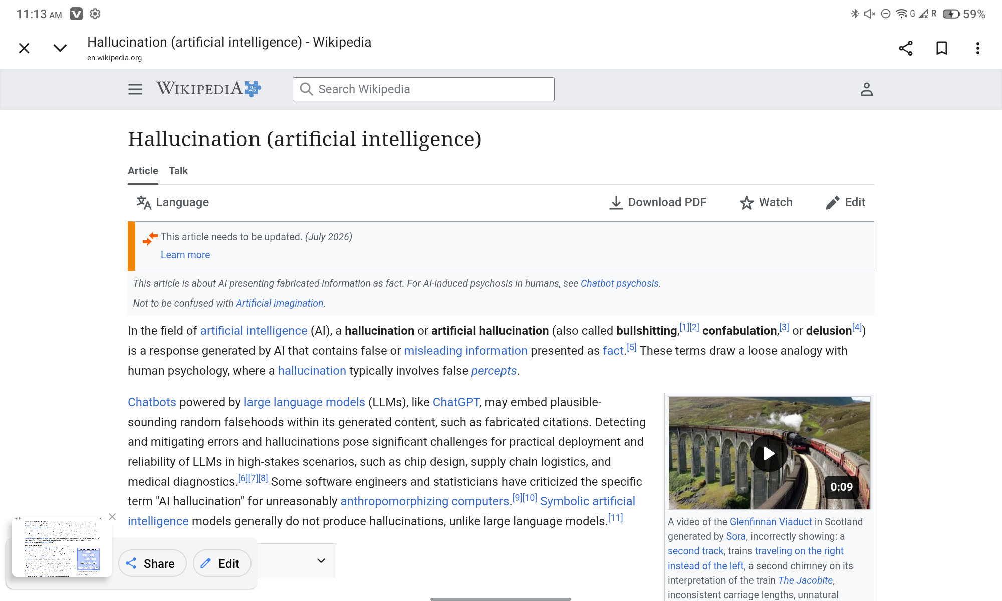
Scenario ID: 1h
Scenario:Review footer links.
Test Steps:
- Scroll to the bottom.
- Open the Privacy Policy link.
Screenshots:
